**INDEX**

|  |  |  |
| --- | --- | --- |
| **Sl.no** | **Particulars** | **Page No.** |
| 1 | Introduction |  |
| 2 | Technology Used |  |
| 3 | What can Python do? |  |
| 4 | Why Python? |  |
| 5 | Hardware and Software used |  |
| 6 | Aim |  |
| 7 | Program Code |  |
| 8 | Output |  |
| 9 | Flowchart |  |
| 10 | Bibliography |  |

**INTRODUCTION**

This is a project based on a **Personality test Quiz.** This quiz will help the user to know about his personality type based on his/her responses. It will also let him/her know about the number of people (who have taken the test) falling in his personality type via graphical representation. I have used Python for creating this quiz. This project is a simple presentation on how Python is effective in creating a quiz, and usage of graphs and CSV files.

**TECHNOLOGY USED**

Programming Language – Python

* **Development:** Python programming language was initially designed by Guido Van Rossum in February 1991 and developed by Python Square Foundation.
* **Easy to Use:** Python is compact and easy to use object-oriented language with very simple syntax rules.
* **Expressive Language:** Python is an expressive language – fewer lines of code and simpler syntax as compared to other popular programming languages like C++, Java, etc.
* **Versatile:** Python is versatile. It can be used for many different tasks, from web development to machine learning.

2

**WHAT CAN PYTHON DO?**

1. **Web Development:** Python is often used to develop the back end of a website or application – the parts that a user doesn’t see.
2. **Software testing and prototyping:** In software development, Python can aid in tasks like bug tracking and testing. With Python, software developers can automate testing for new products or features.
3. **Everyday tasks:** Python can be used for everyday tasks such as keeping track of stock market, sending yourself a text reminder to carry an umbrella anytime it’s raining, etc.

1. **Data Analysis and Machine learning:** Python helps data analysts and other professionals to conduct complex statistical calculations, create data visualizations, build machine learning algorithms, manipulate and analyse data, and complete other data-related tasks.

3

**WHY PYTHON?**

* **Cross-platform Language**: Python can run equally well on variety of platforms – Windows, Linus/UNIX, smartphones, etc.
* **Simple syntax:** Python has a simple syntax similar to the English language.
* **Expressive language:** Python is an expressive language with fewer lines of code and simpler syntax as compared to other popular programming languages like C++, Java, etc.
* **Quick prototyping:** Python runs on an interpreter system. This means that the code can be executed as soon as it is written. This means that prototyping can be very quick.
* **Procedural way treatment:** Python can be treated in a procedural way, an object-oriented way or a functional way.

**HARDWARE USED**

|  |  |
| --- | --- |
| **Operating System** | Windows 10 and above |
| **Processor** | Intel Core I5 @ 2.16Ghz |
| **RAM** | 4GB |
| **Hard disk** | SSD 500GB |

**SOFTWARE USED**

1. Windows OS
2. Python

**AIM**

To create a quiz through which users can get an idea about their type of personality and can also know about the number of people (those who have taken the test) who land in their personality type.

**PROGRAM**

**CODE**

import matplotlib.pyplot as pl

import numpy as np

import pandas as pd

'''df=pd.DataFrame(['The Shy Worrier',

'The Careful Plodder',

'The Loyal Friend',

'The Lively Center of Attention',

'The Natural Leader',

'The Vain, Self-Centered Leader'])'''

df = pd.read_csv("D:\\OKK.csv",index_col=0)

print(df)

while True:

name = input("Enter your name: ")

print("Hello", name, "\U0001F600 \nlets begin with the personality test!")

print(" ")

print("NOTE: Please keep Caps Lock button 'ON' during the test!")

score = 0

p1 = 'The Shy Worrier'

p2 = 'The Careful Plodder'

p3 = 'The Loyal Friend'

p4 = 'The Lively Center of Attention'

p5 = 'The Natural Leader'

p6 = 'The Vain, Self-Centered Leader'

while True:

Q1 = input("I feel most energtic and focused: \n A. In the morning \n B. During the afternoon and early evening \n C. Late at night \n [A/B/C]? ")

if Q1 == 'A':

score = score + 1

break

elif Q1 == 'B':

score = score + 4

break

elif Q1 == 'C':

score = score + 6

break

elif Q1 not in ('A', 'B', 'C'):

print(" ")

print("Please choose a valid option! / Keep Caps Lock button 'ON'!")

continue

else:

break

while True:

Q2 = input("When I walk, I tend to do it: \n A. Fairly fast, with long steps \n B. Fairly fast, with small steps \n C. Less fast, head up, looking the world in the face \n D. Less fast, head down \n E. Very slowly \n [A/B/C/D/E]? ")

if Q2 == 'A':

score = score + 6

break

elif Q2 == 'B':

score = score + 4

break

elif Q2 == 'C':

score = score + 7

break

elif Q2 == 'D':

score = score + 2

break

elif Q2 == 'E':

score = score + 1

break

elif Q2 not in ('A', 'B', 'C', 'D', 'E'):

print(" ")

print("Please choose a valid option! / Keep Caps Lock button 'ON'!")

continue

else:

break

while True:

Q3 = input("When you speak to people, you tend to: \n A. Stand with your arms folded \n B. Have your hands clasped \n C. Have one or both of your hands on your hips \n D. Touch or push the person to whom you are talking \n E. Play with your ear or hair, touch your chin, or smooth your hair \n [A/B/C/D/E]? ")

if Q3 == 'A':

score = score + 4

break

elif Q3 == 'B':

score = score + 2

break

elif Q3 == 'C':

score = score + 5

break

elif Q3 == 'D':

score = score + 7

break

elif Q3 == 'E':

score = score + 6

break

elif Q3 not in ('A', 'B', 'C', 'D', 'E'):

print(" ")

print("Please choose a valid option! / Keep Caps Lock button 'ON'!")

continue

else:

break

while True:

Q4 = input("When you're relaxed, you usually sit with: \n A. Your knees bent, with your legs neatly side by side \n B. Your legs crossed \n C. Your legs stretched out or straight \n D. One leg curled under you \n [A/B/C/D]? ")

if Q4 == 'A':

score = score + 4

break

elif Q4 == 'B':

score = score + 6

break

elif Q4 == 'C':

score = score + 2

break

elif Q4 == 'D':

score = score + 1

break

elif Q4 not in ('A', 'B', 'C', 'D'):

print(" ")

print("Please choose a valid option! / Keep Caps Lock button 'ON'!")

continue

else:

break

while True:

Q5 = input("When you find something really funny, you usually give: \n A. A big, appreciative laugh \n B. A laugh, but not a loud one \n C. A quiet chuckle \n D. A sheepish smile \n [A/B/C/D]? ")

if Q5 == 'A':

score = score + 6

break

elif Q5 == 'B':

score = score + 4

break

elif Q5 == 'C':

score = score + 3

break

elif Q5 == 'D':

score = score + 5

break

elif Q5 not in ('A', 'B', 'C', 'D'):

print(" ")

print("Please choose a valid option! / Keep Caps Lock button 'ON'!")

continue

else:

break

while True:

Q6 = input("When you enter a party or social gathering, you tend to: \n A. Make a loud entrance, so that everyone notices you \n B. Make a quiet entrance, looking around for someone you know \n C. Make the quietest entrance, trying to stay unnoticed \n [A/B/C]? ")

if Q6 == 'A':

score = score + 6

break

elif Q6 == 'B':

score = score + 4

break

elif Q6 == 'C':

score = score + 2

break

elif Q6 not in ('A', 'B', 'C'):

print(" ")

print("Please choose a valid option! / Keep Caps Lock button 'ON'!")

continue

else:

break

while True:

Q7 = input("If you're focused on a task and you're interrupted, you're likely to: \n A. Welcome the break \n B. Feel extremely irritated \n C. Vary between these two extremes \n [A/B/C]? ")

if Q7 == 'A':

score = score + 6

break

elif Q7 == 'B':

score = score + 2

break

elif Q7 == 'C':

score = score + 4

break

elif Q7 not in ('A', 'B', 'C'):

print(" ")

print("Please choose a valid option! / Keep Caps Lock button 'ON'!")

continue

else:

break

while True:

Q8 = input("Your favourite colour is: \n A. Red/Orange \n B. Black \n C. Yellow/Light blue \n D. Green \n E. Dark blue/Purple \n F. White \n G. Brown/Gray \n [A/B/C/D/E/F/G]? ")

if Q8 == 'A':

score = score + 6

break

elif Q8 == 'B':

score = score + 7

break

elif Q8 == 'C':

score = score + 5

break

elif Q8 == 'D':

score = score + 4

break

elif Q8 == 'E':

score = score + 3

break

elif Q8 == 'F':

score = score + 2

break

elif Q8 == 'G':

score = score + 1

break

elif Q8 not in ('A', 'B', 'C', 'D','E', 'F', 'G'):

print(" ")

print("Please choose a valid option! / Keep Caps Lock button 'ON'!")

continue

else:

break

while True:

Q9 = input("Before you fall asleep, you're usually lying: \n A. Stretched out on your back \n B. Stretched out face down on your stomach \n C. On your side, slightly curled \n D. With your head on one arm \n E. With your head under the covers \n [A/B/C/D/E]? ")

if Q9 == 'A':

score = score + 7

break

elif Q9 == 'B':

score = score + 6

break

elif Q9 == 'C':

score = score + 4

break

elif Q9 == 'D':

score = score + 2

break

elif Q9 == 'E':

score = score + 1

break

elif Q9 not in ('A', 'B', 'C', 'D', 'E'):

print(" ")

print("Please choose a valid option! / Keep Caps Lock button 'ON'!")

continue

else:

break

while True:

Q10 = input("When you dream, you're often: \n A. Falling \n B. Fighting or struggling \n C. Searching for something or somebody \n D. Flying or floating \n E. You usually have dreamless sleep \n F. Your dreams are always pleasant \n [A/B/C/D/E/F]? ")

if Q10 == 'A':

score = score + 4

break

elif Q10 == 'B':

score = score + 2

break

elif Q10 == 'C':

score = score + 3

break

elif Q10 == 'D':

score = score + 5

break

elif Q10 == 'E':

score = score + 6

break

elif Q10 == 'F':

score = score + 1

break

elif Q10 not in ('A', 'B', 'C', 'D', 'E', 'F'):

print(" ")

print("Please choose a valid option! / Keep Caps Lock button 'ON'!")

continue

else:

break

print(" ")

print("Your score is: ")

print(score)

print(" ")

print("The kind of personality you are: ")

print(" ")

if score <=20:

df.iloc[0,1]=df.iloc[0,1]+1

print(df.iloc[0,0])

print("People think that you're shy, nervous and indecisive, someone who needs looking after, who always wants someone else to make the decisions and who doesn't want to get involved with anyone or anything. They see you as a worrier who always sees problems that don't exist. Some people think you're boring. Only those who know you well know that you aren't" )

elif score <=30 and score >20:

df.iloc[1,1]=df.iloc[1,1]+1

print(df.iloc[1, 0])

print("Your friends see you as painstaking and fussy. They see you as very cautious, extremely careful, a slow and steady plodder. It'd really surprise them if you ever did something impulsively or on the spur of the moment, expecting you to examine everything carefully from every angle and then, usually decide against it. They think this reaction is caused partly by your careful nature")

elif score <=40 and score>30:

df.iloc[2,1] =df.iloc[2,1]+1

print(df.iloc[2, 0])

print("Others see you as sensible, cautious, careful & practical. They see you as clever, gifted, or talented, but modest. Not a person who makes friends too quickly or easily, but someone who's extremely loyal to friends you do make and who expects the same loyalty in return. Those who really get to know you realize it takes a lot to shake your trust in your friends, but equally that it takes you a long time to get over if that trust is ever broken")

elif score <=50 and score>40:

df.iloc[3,1] = df.iloc[3,1] +1

print(df.iloc[3, 0])

print("Others see you as fresh, lively, charming, amusing, practical, and always interesting; someone who's constantly in the center of attention, but sufficiently well-balanced not to let it go to their head. They also see you as kind, considerate, and understanding; someone who'll always cheer them up and help them out")

elif score <=60 and score>50:

df.iloc[4,1]=df.iloc[4,1]+1

print(df.iloc[4, 0])

print("Others see you as an exciting, highly volatile, rather impulsive personality; a natural leader, who's quick to make decisions, though not always the right ones. They see you as bold and adventuresome, someone who will try anything once; someone who takes chances and enjoys an adventure. They enjoy being in your company because of the excitement you radiate")

else:

df.iloc[5,1]=df.iloc[5,1]+1

print(df.iloc[5, 0])

print("Others see you as someone they should handle with care. You are seen as vain, self-centered and who is extremely dominant. Others may admire you, wishing they could be more like you, but don't always trust you, hesitating to become deeply involved with you")

print(" ")

print("60 & up: The Vain, Self-Centered Leader \n50-60: The Natural Leader \n40-50: The Lively Center of Attention\n30-40: The Loyal Friend\n20-30: The Careful Plodder\n0-20: The Shy Worrier")

if input ("Do you want to restart? (Y/N): ") == 'N':

print("Exiting...")

break

print(df)

df.to_csv("D:\\OKK.csv")

x = [p1, p2, p3, p4, p5, p6]

y = df ['Count']

pl.figure(figsize = (15, 15))

pl.bar(x, y, color = 'maroon')

pl.xlabel('Personality Type')

pl.ylabel('Number of person')

pl.title('PERSONALITY TEST')

pl.show()

**SAMPLE**

**OUTPUT**

**QUESTIONS TO USER**

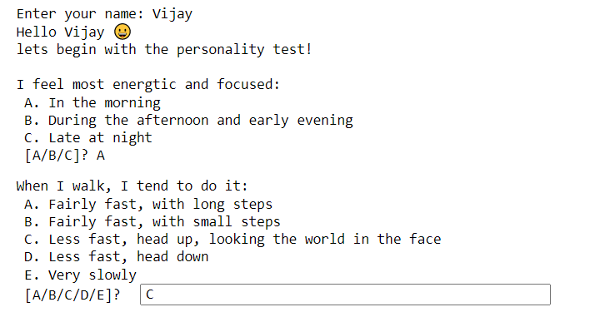

**RESULT**

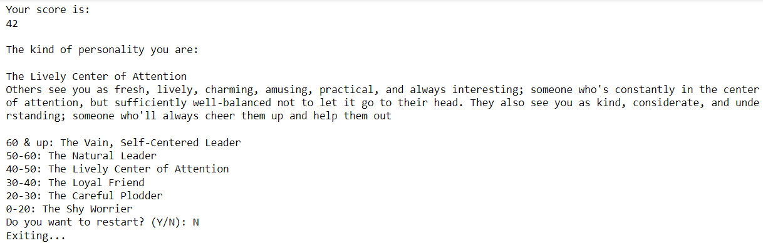

**RESULT BEING STORED**

**IN CSV FILE**

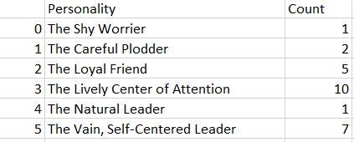

**RESULT IN GRAPHICAL FORM**

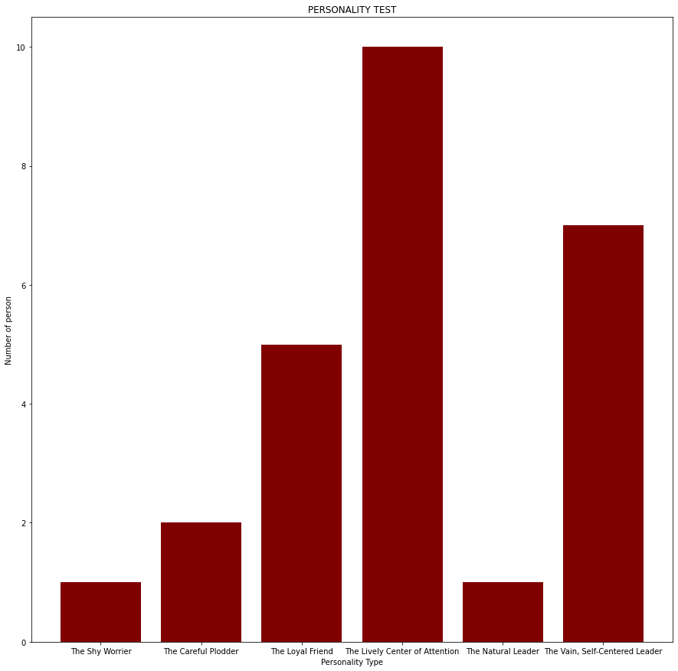

**INVALID INPUT**

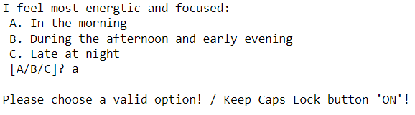

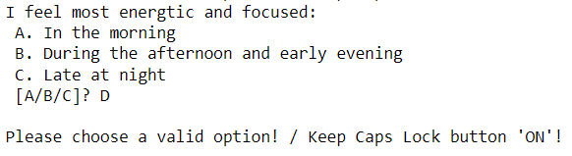

**BIBLIOGRAPHY**

* Sumita Arora Textbook Informatics Practices Class XII
* [www.w3school.com](http://www.w3school.com)